Tennessee's K-3 Class Size Study
Filename | star.sav
Overview | The Student/Teacher Achievement Ratio (STAR) was a four-year longitudinal class-size study funded by the Tennessee General Assembly and conducted by the State Department of Education. Over 7,000 students in 79 schools were randomly assigned into one of three interventions: small class (13 to 17 students per teacher), regular class (22 to 25 students per teacher), and regular-with-aide class (22 to 25 students with a full-time teacher's aide). Classroom teachers were also randomly assigned to the classes they would teach. The interventions were initiated as the students entered school in kindergarten and continued through third grade.
Source | http://www.heros-inc.org/star.htm
Sample size | 1224 students who were randomly assigned to small classes (n = 858) or regular classes (n = 366) during all four of their K-3 years.

Theory: Small class sizes are conducive to learning because they provide students the one-on-one attention they need for optimized learning.

Research Question: In the population of Tennessee early elementary schoolers, does attending small K-3 classes improve third-grade test scores? (Note: we can ask, and answer, a causal question because students were randomized into small and regular class. Because of the randomization, the two groups begin equal in expectation. If the finish different, then that difference is reasonably attributable the experimental condition.)

Outcome Variable:
READING3 | 3rd grade reading scores | Numeric
Predictor Variable:
SMALLK123 | 1 = the student was assigned to small classes K-3  0 = the student was assigned to regular classes K-3 | Categorical
Other Variables:
READING1 | 1st grade reading scores | Numeric
READING2 | 2nd grade reading scores | Numeric

Post Hole 1—Use exploratory data analytic techniques to investigate the relationship between two variables.

Explore READING3 vs. SMALLK123: (A checklist is generally good, but interpret the magnitude with a careful sentence.)
Direction: Positive
Outliers: There appears to be high outliers in both groups.
Linearity: Necessarily
Magnitude: On average, students in small classes score 8 points higher on the 3rd grade reading test than students in regular classes.
Strength: Weak
*
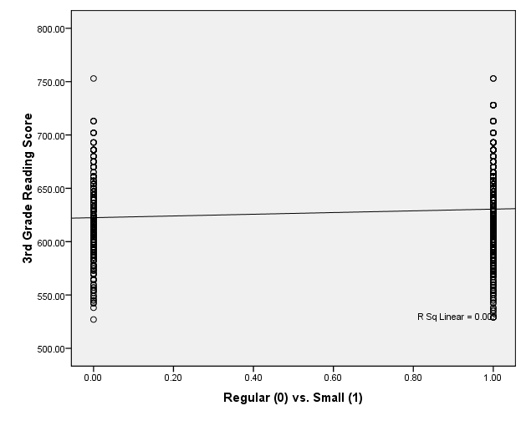

Post Hole 5—Interpret an R² statistic verbally and, using Boolean circles, graphically.
Post Hole 6—State the null hypothesis of a test for statistical significance; reject (or not) the null hypothesis; draw an inference (or not) from a sample to a population.
Post Hole 7—Interpret a confidence interval from a frequentist perspective and from a Bayesian perspective.
Interpret the R² statistic: (One careful sentence is good.)
SMALLK123 predicts about 1% of the variation in READING3. | READING3  SMALLK123
*
Test for statistical significance:
The null hypothesis is that there is no relationship in the population. If the null were true, we would expect to observe a relationship as extreme (or more extreme) as ours about 1% of the time. Therefore, we reject the null hypothesis, and we conclude that, in the population of Tennessee K-3 students, students from smaller classes score higher than students from regular classes.
*
Interpret the confidence interval: (Use both perspectives.)
3.3 to 12.7 provides a range of plausible values for the population average effect of small class sizes. In my life, 5% of such ranges will fail.

In the absence of further information, we are 95% confident that the true average effect of small class sizes on 3rd grade reading scores is between 3.3 and 12.7 in the population.
*
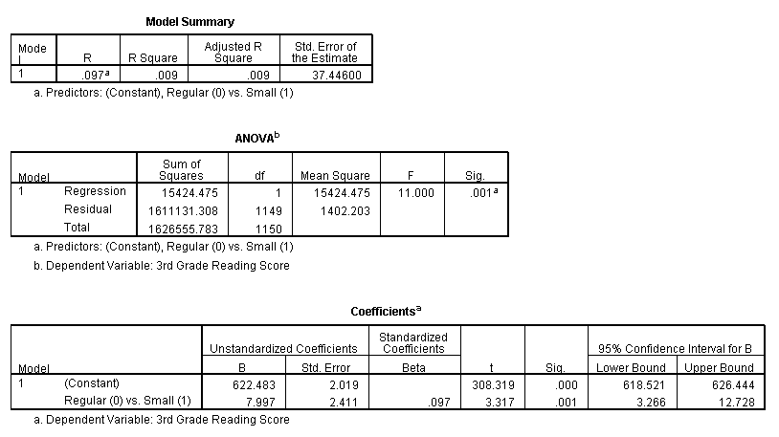

Post Hole 4—Interpret a correlation matrix.

Interpret the correlation matrix :
The three correlations between reading scores (1st, 2nd, and 3rd grade, respectively) and the treatment/intervention variable are all around 0.10 and statistically significant. I wonder about practical significance. Is this strong enough to justify the costs of smaller class sizes?

The three reading tests are all highly correlated among themselves ( .65 < r < .74). This is not surprising since they measure the same thing, although at different times.
*
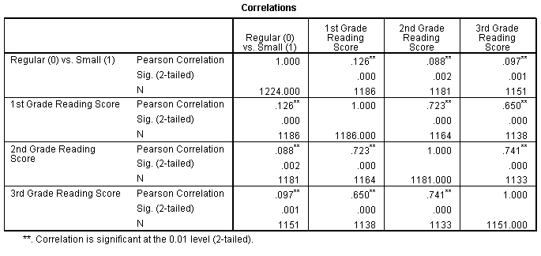

Post Hole 2—Use exploratory data analytic techniques to describe the distribution of a variable.

Explore READING3: (A checklist is good.)
Spread: Midspread = 52, Whiskers = 78, RLB = 527, RUB = 732, There are a few positive outliers consistent with the positive skew.
Location: Median = 629
Shape: Slightly positively skewed
*
Explore SMALLK123: (A checklist is good.)
70% of students were assigned to small classes. 30% of students were assigned to regular classes.
*
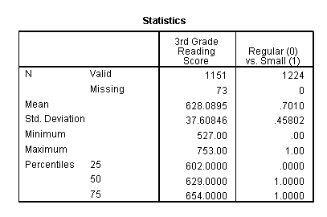
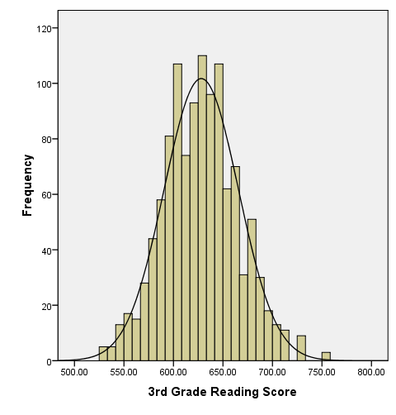 | 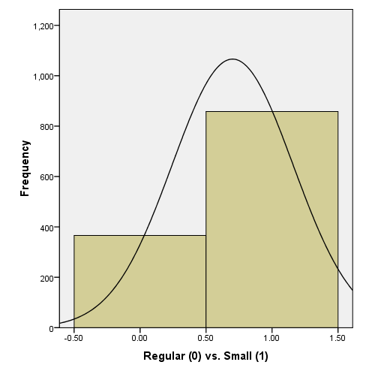

Post Hole 3—Conduct a z-score transformation by hand from a small data set.

SMALLK123: 0 1 1 0 1 1 0 1 1 1

Please show your work:
Raw | Mean | Mean Dev. | Sq. Mean Dev. | Z
0 | 0.7 | -0.7 | 0.49 | -1.44914
0 | 0.7 | -0.7 | 0.49 | -1.44914
0 | 0.7 | -0.7 | 0.49 | -1.44914
1 | 0.7 | 0.3 | 0.09 | 0.621059
1 | 0.7 | 0.3 | 0.09 | 0.621059
1 | 0.7 | 0.3 | 0.09 | 0.621059
1 | 0.7 | 0.3 | 0.09 | 0.621059
1 | 0.7 | 0.3 | 0.09 | 0.621059
1 | 0.7 | 0.3 | 0.09 | 0.621059
1 | 0.7 | 0.3 | 0.09 | 0.621059

*
Please note the mean of the raw distribution: | .7
Please note the sum of squared mean deviations: | 2.1
Please note the variance of the raw distribution: | .23
Please note the standard deviation of the raw distribution: | .48

