Data Set: National Education Longitudinal Study (NELS)
“A nationally representative sample of eighth-graders were first surveyed in the spring of 1988. A sample of these respondents were then resurveyed through four follow-ups in 1990, 1992, 1994, and 2000. On the questionnaire, students reported on a range of topics including: school, work, and home experiences; educational resources and support; the role in education of their parents and peers; neighborhood characteristics; educational and occupational aspirations; and other student perceptions.” http://nces.ed.gov/surveys/NELS88/

Theory: Socioeconomic status is a major predictor of academic achievement because wealth and privilege permit access to otherwise inaccessible educational resources.

Research Question: We know the socioeconomic status (SES) is correlated with 10th grade reading achievement, but how strong is the correlation compared to 8th grade reading achievement, 8th grade math achievement, 8th grade locus of control and sex?

Outcome: READING10TH, an IRT scaled 10th grade reading score
Question Predictors:
SES8TH, a composite measure of SES taken in the 8th grade
READING8TH, an IRT scaled 8th grade reading score
MATH8TH, an IRT scaled 8th grade math score
LOCUSOFCONTROL8TH, an 8th grade measure of locus control for which higher values indicate greater internal locus of control.
FEMALE, a dichotomous variable, 1 = female, 0 = male

Note on LOCUSOFCONTROL8TH, from Wikipedia: Locus of control in social psychology refers to the extent to which individuals believe that they can control events that affect them. Understanding of the concept was developed by Julian B. Rotter in 1954, and has since become an important aspect of personality studies. Individuals with a high internal locus of control believe that events result primarily from their own behavior and actions. Those with a low internal locus of control believe that powerful others, fate, or chance primarily determine events.

Post Hole 4—Interpret a correlation matrix.

Interpret the correlation matrix :
Note that the final exam will only have three correlations in the correlation matrix (not fifteen correlations!).

All the predictors have a positive correlation with our outcome, READING10TH. The 8th grade test scores, READING8TH and MATH8TH, have by far the strongest correlations with READING10TH (r = .72 and r = .63, respectively).

Most of the predictors have a positive correlation with each other. The strongest is between the 8th grade test scores.

There do not appear to be any extreme outlier problems. In general, there do not appear to be linearity problems, but I would give a closer look to READING10TH vs. READING8TH and READING10TH vs. MATH8TH.

The following is more than is necessary for the sketch that the posthole requires:

10th grade reading is correlated with 8th grade SES (r = 0.37). We see, however, that the correlation is not nearly as strong as the correlation between 10th grade reading and 8th grade reading (r = 0.72) nor as strong as the correlation between 10th grade reading and 8th grade math (r = 0.63). Nevertheless, the SES correlation is stronger than the correlation between 10th grade reading and 8th grade locus of control and (r = 0.22). Thus, having a high SES in 8th grade is more predictive of 10th grade reading than having a high internal locus of control in 8th grade.

The predictors (except for FEMALE) are generally positively correlated among themselves with Pearson correlations between 0.16 and 0.67. FEMALE is slightly negatively correlated with SES8TH (for a reason that I cannot fathom!) and slightly positively correlated with READING10TH, READING8TH, and LOCUSOFCONTROL8TH. Interestingly, FEMALE has a slightly stronger correlation with READING10TH (r = 0.17) than READING8TH (r = 0.11), which suggests that the gender achievement gap is growing in high school.

There do not appear to be any extreme outlier problems. In general, there do not appear to be linearity problems, but I would give a closer look to READING10TH vs. READING8TH and READING10TH vs. MATH8TH.
*
READING10TH SES8TH READING8TH MATH8TH LOCUSOFCONTROL8TH FEMALE
READING10TH 1.00 0.37 0.72 0.63 0.22 0.17
SES8TH 0.37 1.00 0.38 0.44 0.17 -0.12
READING8TH 0.72 0.38 1.00 0.67 0.22 0.11
MATH8TH 0.63 0.44 0.67 1.00 0.22 -0.03
LOCUSOFCONTROL8TH 0.22 0.17 0.22 0.22 1.00 0.01
FEMALE 0.17 -0.12 0.11 -0.03 0.01 1.00

Be sure to check the scatterplot matrix below for outlier and/or linearity problems.

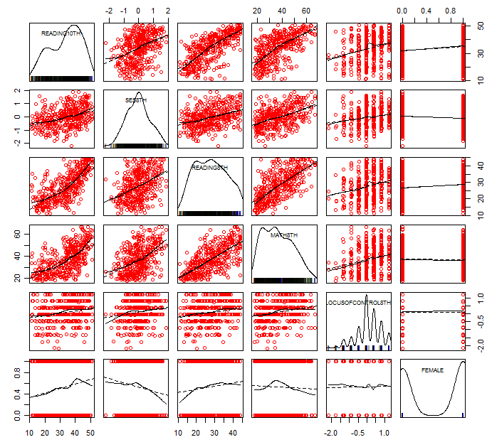

Post Hole 3—Conduct a z-score transformation by hand from a small data set.

Reading Scores: 20 30 30 30 30 30 30 40 50 60

Please show your work:
RAW | MEAN | MEAN DEVIATION | MEAN DEVIATION SQUARED | Z SCORE
20 | 35 | -15 | 225 | -1.27279
30 | 35 | -5 | 25 | -0.42426
30 | 35 | -5 | 25 | -0.42426
30 | 35 | -5 | 25 | -0.42426
30 | 35 | -5 | 25 | -0.42426
30 | 35 | -5 | 25 | -0.42426
30 | 35 | -5 | 25 | -0.42426
40 | 35 | 5 | 25 | 0.424264
50 | 35 | 15 | 225 | 1.272792
60 | 35 | 25 | 625 | 2.12132

*
Please note the mean of the raw distribution: | 35
Please note the sum of squared mean deviations: | 1250
Please note the variance of the raw distribution: | 138.9
Please note the standard deviation of the raw distribution: | 11.8

Post Hole 1—Use exploratory data analytic techniques to investigate the relationship between two variables.

Explore READING10TH vs. READING8TH: (A checklist is generally good, but interpret the magnitude with a careful sentence.)
D: positive
O: A few students scored moderately high in the 8th but very low in the 12th.
L: linear
M: If we compare two students who scored ten points apart in the 8th, we predict on average that, in the 10th, they will score 8 points apart with the higher scorer still scoring higher.
A
S: Moderately strong. The data hug the line, but not as tightly as I might expect given that they are tests of the same subject. In reading skill, students are changing positions relative to one another during high school.
*
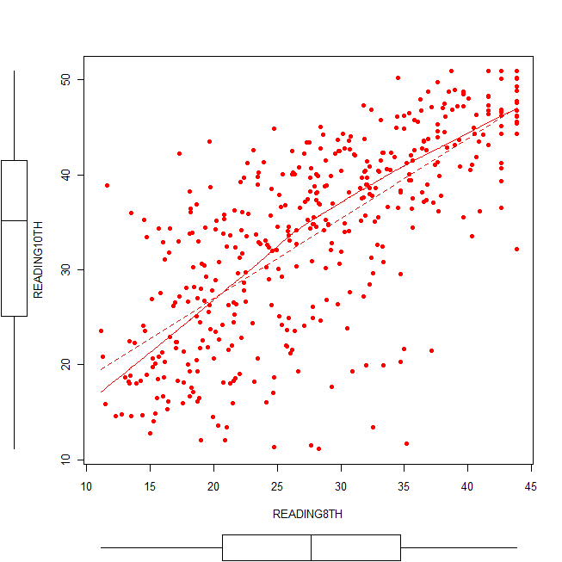

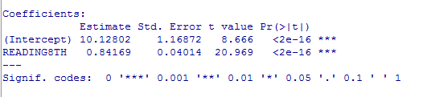

Post Hole 1—Use exploratory data analytic techniques to investigate the relationship between two variables.

Puzzle: If there is a positive correlation between 10th-grade reading scores and 8th-grade reading scores, does that imply scores improved?

Explore READING10THPLUS20 vs. READING8TH: (A checklist is generally good, but interpret the magnitude with a careful sentence.)

Note that READING10THPLUS20 is just a linear transformation of READING10TH, where I added 20 to every student’s raw READING10TH score. This transformation makes all the students “improve” more in reading.

Hint: Just cut and paste your answer from above! Linear transformations do not change the shape of the univariate or bivariate distribution. I.e., neither the histogram nor the scatterplot will change, except for the numbers on the axes. By adding twenty to every 10th grade score, what exactly did we do to the numbers on the axes? We did not change the x-axis, because we did not change the predictor. We did change the y-axis, because we changed the y-variable. However, we did not expand the y-axis, because we did not multiply the scores which would increase the slope, and we did not contract the y-axis, because we did not divide the scores which would decrease the slope. We just shifted the y-axis. In doing so, the only thing we changed was the y-intercept, which I assume you are not reporting, because zero is outside the range of our data. Therefore, you will cut and paste your answer from above!

Examine the following correlation matrix:

READING8TH READING10TH READING10THPLUS20 READING10THMINUS20
READING8TH 1.00 0.72 0.72 0.72
READING10TH 0.72 1.00 1.00 1.00
READING10THPLUS20 0.72 1.00 1.00 1.00
READING10THMINUS20 0.72 1.00 1.00 1.00

Notice that 8th grade reading scores have the same exact correlation with 10th grade scores whether or not everybody in the 10th grade gets a 20-point boost (or a 20-point penalty). Pearson correlations cannot track absolute improvement because of standardization! If everybody’s score goes up (or down), then the mean score goes up, but the Pearson correlation zeroes out the mean in standardizing to ZREADING8TH and ZREADING10TH and ZREADING10THPLUS20 and ZREADING10THMINUS20.

Then, is there any way to see improvement? Yes. We can compare the 8th grade scores to the predicted 10th grade scores. Let’s go back to the real data for this: READING8TH and READING10TH. Let’s look at the lowest-scoring student in the 8th grade (READING8TH = 11), the median-scoring student in the 8th grade (READING8TH = 28), and the highest-scoring student in the 8th grade (READING8TH = 43):

Observed  READING8TH | Fitted Model:  $$\text{READI \{}\hat{N}G\text{10}\text{TH}=\text{10}\text{.}1+0\text{.}8\text{READING}8\text{TH}$$ | Predicted  READING10TH | Predicted  Improvement
11 | $\text{READI \{}\hat{N}G\text{10}\text{TH}=\text{10}\text{.}1+0\text{.}8$(11) | 19 | 8
28 | $\text{READI \{}\hat{N}G\text{10}\text{TH}=\text{10}\text{.}1+0\text{.}8$(28) | 33 | 5
43 | $\text{READI \{}\hat{N}G\text{10}\text{TH}=\text{10}\text{.}1+0\text{.}8$(43) | 45 | 2

Thus, we predict that students will improve. Notice that we need magnitude to make the prediction, not strength. Also notice that we predict the lowest scoring student will improve the most and the highest scoring student to improve the least! Trick question: Why would the lowest scoring 8th-grade students tend to improve more than the highest scoring 8th-grade students?

There are many possible explanations. The true answer may be a combination of those explanations. Here is one probable explanation:

Regression Toward The Mean (aka Reversion To The Mean., aka Reversion To Mediocrity)

Careful, it does not mean what it sounds like it means!!!

What is regression toward the mean? It is a common mistake/fallacy/confusion in life and statistics. In fact, the statistician, Galton, who coined the term, misunderstood it, and that misunderstanding is reflected in the name! Nevertheless, the name stuck, and this is why we call regression “regression.” I am not going to define “regression toward the mean,” but I will elucidate our current example of regression toward the mean in a general way.

A student’s 8th grade test score is a combination of skill and luck, and the student’s 10th grade test score is a combination of skill and luck. A student can be high-skilled or low-skilled for a test. A student can be lucky or unlucky for test. The highest scoring 8th grader was probably high-skilled for that test and lucky for that test. The lowest scoring 8th grader was probably low-skilled for that test and unlucky for that test. Skills are fairly stable, but they can improve, and as teachers and students we struggle to improve them. It would be great if we had tests that measured skills and skills alone with no luck factor, but we don’t. Scores are confounded with luck. Because of the luck factor, we get regression to the mean. Skills are fairly stable, but luck is all over the place. For our predictions, how should we take into consideration luck? Luck should add uncertainty to our predictions, but as for the predictions themselves, we shouldn’t assume good luck or bad luck. Rather, we should assume zero luck.

Recall the (probably) high-skilled and (probably) lucky 8th grader who scored highest on the 8th grade test (READING8TH = 43). Fast forward to the 10th grade. When she takes the 10th grade test, she can count on her skills, but she can’t count on luck. As data analysts, neither can we count on luck. She gets our highest prediction ($\text{READI \{}\hat{N}G\text{10}\text{TH}$= 45), but it’s not so much higher than her 8th grade score because we’re assuming that she was lucky in the 8th grade but that she won’t be lucky (or unlucky) in the 10th grade.

Recall the (probably) low-skilled and (probably) unlucky 8th grader who scored lowest on the 8th grade test (READING8TH = 11). Fast forward to the 10th grade. When she takes the 10th grade test, she may not have super-high skills, but she probably won’t have super-bad luck. She gets our lowest prediction ($\text{READI \{}\hat{N}G\text{10}\text{TH}$= 19), but for her we predict the most improvement in scores. Even if everybody improved his/her skill by exactly the same amount, say 5 points, we would still predict that she would have the greatest improvement in score, because we know that her score is a combination of skill and luck, and we have reason to believe that she had bad luck in the 8th grade, and we have no reason to believe that she will have bad luck in the 10th grade.

Regression to the mean is an artifact of luck. (It’s often mistaken for an artifact of statistics, but regression to the mean happens with or without statistics.) As humans, we make predictions all the time, and most of those predictions are not statistical. We should always temper our predictions by accounting for luck.

Football: Will the team with best record last year have the same record next year? Probably not. To get that record required many lucky breaks. Will the team with the worst record last year have the same record next year? Probably not. To get that record required many unlucky breaks.

Love: Think about a terrible, terrible, terrible first date (in the romantic comedy sense). The second date will probably be better, because the luck probably won’t be so bad. Think about an amazing, amazing, amazing first date. The second date will probably be worse, because the luck probably won’t be so good. (Note: I am in no way referring to “getting lucky,” because I am assuming that there is no kissing on the first date.)

Finally, although I assume that regression to the mean (i.e., luck) is one explanation, I do not assume that regression to the mean (i.e., luck) is the only explanation! For example, it is possible that low-skilled students actually did improve more than the high-skilled students. Perhaps, low-skilled students got all the attention and educational resources, and high-skilled students were left to their own devices. In this case, regression to the mean amplifies the real difference in improvement. For another example, suppose that the low-skilled students DID NOT improve as much as the high-skilled students. Suppose that the variation in skills increased from the 8th grade to 10th grade, where the “rich got richer, and the poor got poorer.” In this case, regression to the mean masks the real difference in improvement, suggesting just the opposite.

Regression to the mean is a source of confusion not only in statistics but also in everyday life.
How can we look past regression to the mean? We can look at our prediction for the average 8th grade student. Recall that we reasonably suspected that the highest-scoring 8th grader probably had good luck the day of the test and that the lowest-scoring 8th grader probably had bad luck the day of the test. Well, likewise we can reasonably suspect that the average-scoring 8th grader probably had average luck (neither good luck nor bad luck) the day of the test. Thus, our prediction for the average-scoring 8th grader is luck free. Our fitted model gives us reason to believe that there was a 5-point improvement in skills on average. (Of course, be sure to check the linearity and outlier assumptions of the fitted model before we trust what the fitted model has to say.)

D: positive
O: A few students scored moderately high in the 8th but very low in the 12th.
L: linear
M: If we compare two students who scored ten points apart in the 8th, we predict on average that, in the 10th, they will score 8 points apart with the higher scorer still scoring higher.
A
S: Moderately strong. The data hug the line, but not as tightly as I might expect given that they are tests of the same subject. In reading skill, students are changing positions relative to one another during high school.
*
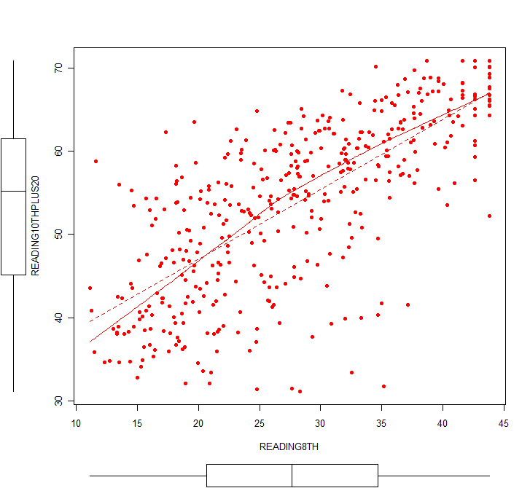

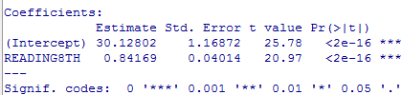

Post Hole 2—Use exploratory data analytic techniques to describe the distribution of a variable.

Explore READING8TH: (A checklist is good.)
Spread: midspread = 14, whisker go down to -1 and up to 55, both outside the range of our data, so we trim them at the min, 11, and the max, 44, and conclude no outliers.
Location: median = 27.65
Shape: symmetric, flat
*
Explore READING10TH: (A checklist is good.)
Spread: midspread = 16, whisker go down to 1 and up to 65, both outside the range of our data, so we time that at the min, 11, and the max, 51, and conclude no outliers.
Location: median = 35.17
Shape: Maybe bimodal? Maybe negatively skewed? Definitely different from the 8th grade!
*
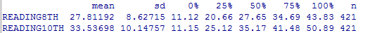
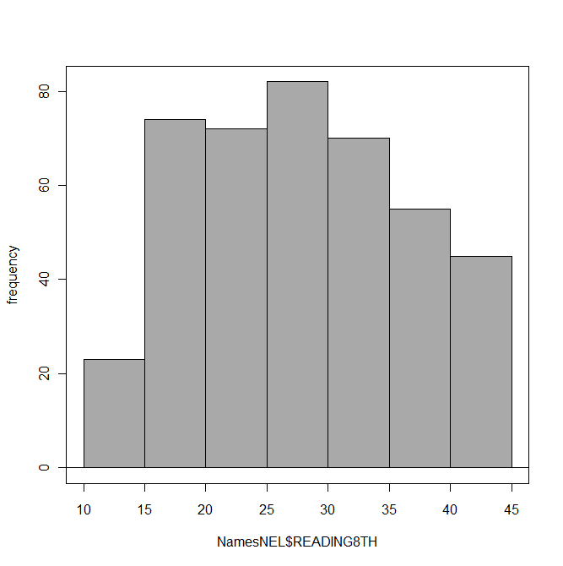 | 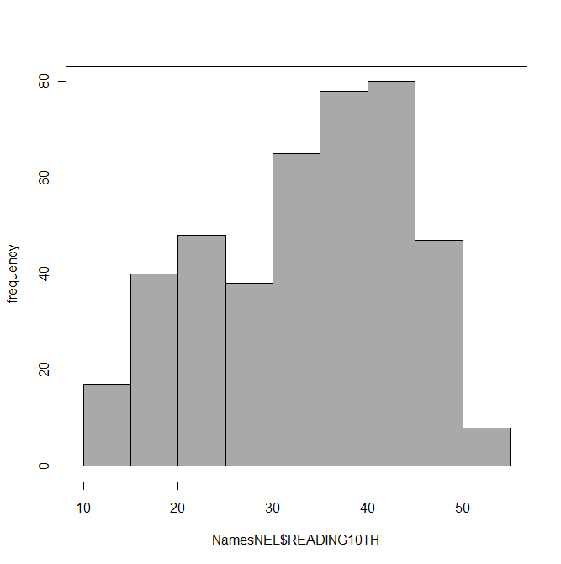
READING8TH | READING10TH

